**Daily Assessment**

**Muhammad Ammar Chaudhry**

**SU92-BSCSM-F23-269**

**BSCS-1G**

**----------------------------------------------------------------------------------------------------**

**Q # 61:**

#include <iostream>

using namespace std;

int main()

{

int decimalNumber;

cout << "Enter decimal no: ";

cin >> decimalNumber;

if (decimalNumber >= 0 && decimalNumber <= 255) {

int binaryArray[8];

int index = 7;

while (decimalNumber > 0 && index >= 0) {

binaryArray[index] = decimalNumber % 2;

decimalNumber /= 2;

index--;

}

cout << "Binary representation: ";

for (int i = index + 1; i < 8; ++i) {

cout << binaryArray[i];

}

cout << endl;

} else

{

cout << "Invalid input. Please enter a number in the range 0-255 " << endl;

}

return 0;

}

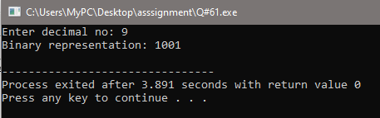

**Q # 62:**

#include <iostream>

using namespace std;

int main()

{

int number;

cout << "Enter a five-digit number: ";

cin >> number;

if (number >= 10000 && number <= 99999) {

int reversedNumber = 0;

while (number > 0) {

reversedNumber = reversedNumber * 10 + number % 10;

number /= 10;

}

cout << "Reversed number: " << reversedNumber << endl;

} else {

cout << "Invalid input. Please enter a five-digit number." << endl;

}

return 0;

}

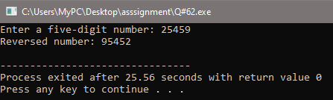

**Q # 63:**

#include <iostream>

using namespace std;

int main()

{

float decimalNumber;

cout << "Enter a decimal number: ";

cin >> decimalNumber;

int wholePart = static_cast<int>(decimalNumber);

float decimalPart = decimalNumber - wholePart;

cout << "Sum of whole part and decimal part: " << wholePart + static_cast<int>(decimalPart * 10) << endl;

return 0;

}

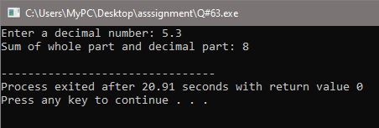

**Q # 64:**

#include <iostream>

using namespace std;

int main()

{

for (int i = 1; i <= 5; i++)

{

cout << "Pakistan\n";

}

return 0;

}

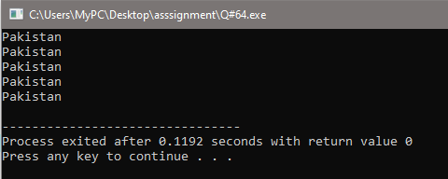

**Q # 65:**

#include <iostream>

using namespace std;

int main() {

for (int i = 1; i <= 10; i++)

{

cout << i << endl;

}

return 0;

}

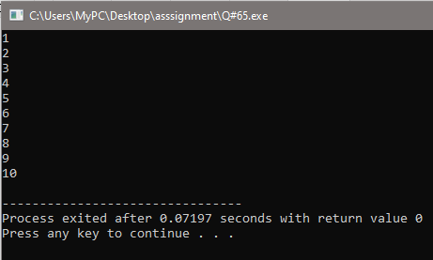

**Q # 66:**

#include <iostream>

using namespace std;

int main()

{

int sum = 0;

cout << "First five numbers: ";

for (int i = 1; i <= 5; ++i)

{

cout << i << " ";

sum += i;

}

cout << "\nSum of the first five numbers: " << sum << endl;

return 0;

}

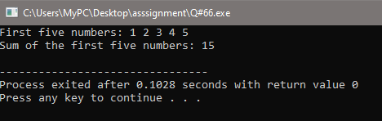

**Q # 67:**

#include <iostream>

using namespace std;

int main()

{

cout << "Number\tSquare" << endl;

for (int i = 1; i <= 5; ++i)

{

cout << i << " \t\t " << i * i << endl;

}

return 0;

}

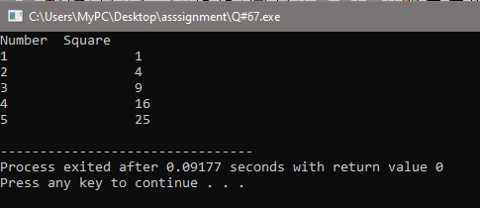

**Q # 68:**

#include <iostream>

using namespace std;

int main()

{

long long number;

cout << "Enter a number: ";

cin >> number;

if (number < 0) {

cout << "Factorial is undefined for negative numbers." << endl;

} else {

long long factorial = 1;

for (int i = 1; i <= number; ++i)

{

factorial *= i;

}

cout << "Factorial of " << number << " is: " << factorial << endl;

}

return 0;

}

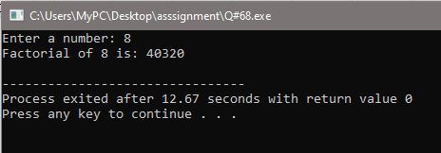

**Q # 69:**

#include <iostream>

using namespace std;

int main()

{

for (int i = 10; i >= 1; i--)

{

cout << i << endl;

}

return 0;

}

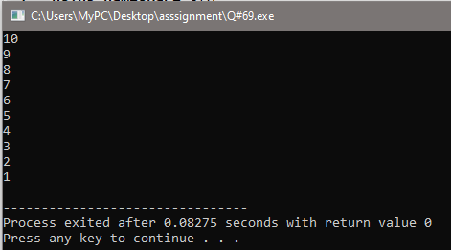

**Q # 70:**

#include <iostream>

using namespace std;

int main()

{

int product = 1;

for (int i = 1; i <= 10; i += 2)

{

product *= i;

}

cout << "Product of all odd numbers from 1 to 10: " << product << endl;

return 0;

}

